EXPERIMENT 6a:

Experiment: Implementation of IoE-Based RFID Tag Identification and Monitoring Using Node-RED

1. Aim
To implement an IoE-based RFID identification and monitoring system using Node-RED to identify RFID tags, process device information, and monitor the received data through a cloud-based MQTT communication flow.

2. Objectives
- To configure Node-RED for RFID tag identification and monitoring.
- To receive RFID tag data through MQTT communication.
- To process tag details using function nodes in Node-RED.
- To transmit device information to the cloud using MQTT topics.
- To monitor tag identification, temperature, status, and timestamp using the Debug panel.

3. Procedure
- Open Node-RED in a web browser and create a new flow.
- Configure the MQTT input and output nodes with the appropriate broker settings and topic ioe/device/scan.
- Create the RFID_TAG section using an Inject node, a Function node named user detail, and an MQTT output node.
- Create the EDGE_DEVICE section using an MQTT input node, a Function node named RFID reader, and an MQTT output node.
- Create the CLOUD section by connecting an MQTT input node to a Debug node.
- Configure the Function nodes to process RFID tag details, device IDs, timestamps, temperature, and identification status.
- Connect the nodes in the required sequence and click Deploy to activate the flow.
- Trigger the RFID data flow and observe the received messages in the Debug panel.
- Verify the tag ID, device ID, timestamp, temperature, and status in the displayed output.

4.Output
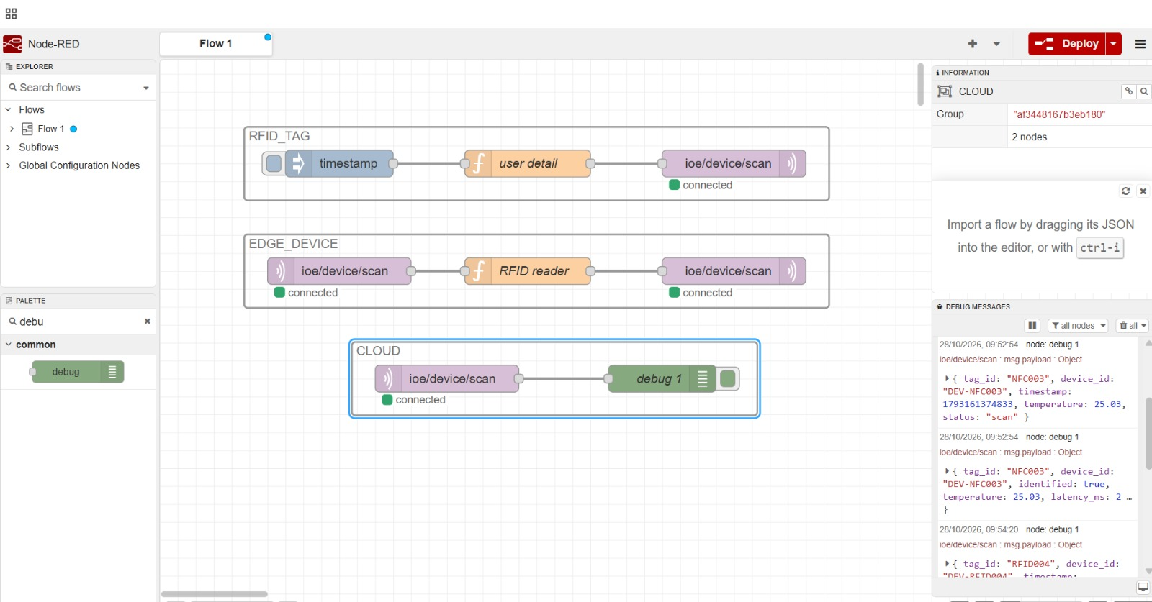

5. Result
The RFID-based IoE monitoring flow was implemented successfully using Node-RED. RFID tag and device information were processed and transmitted through MQTT communication. The received data, including tag ID, device ID, timestamp, temperature, and identification status, was displayed in the Debug panel, demonstrating successful data exchange between the edge device and cloud flow.

